Step 1 = Create student

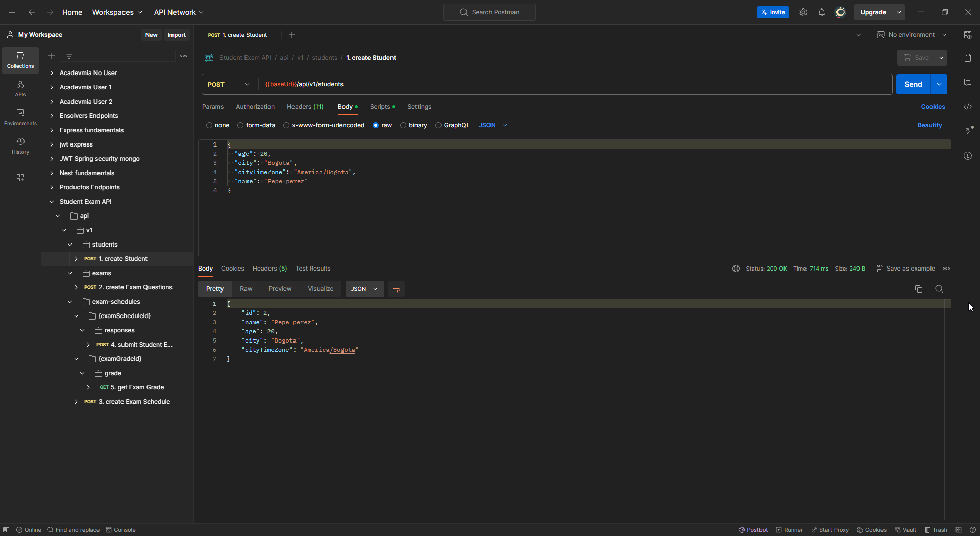

Step 2 = Create Exam

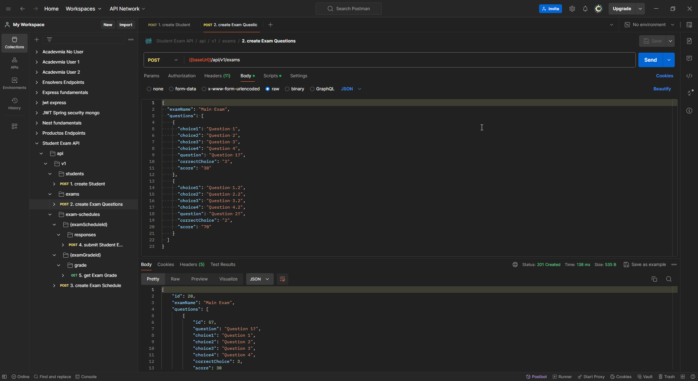It's important to write question IDs because they will be necessary for step 4.

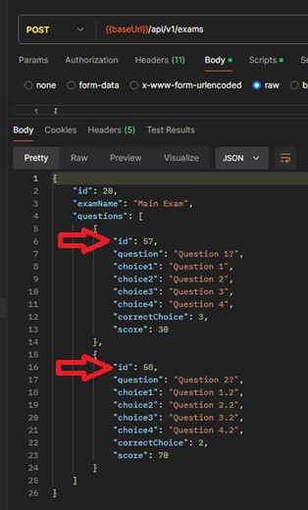

Step 3 =

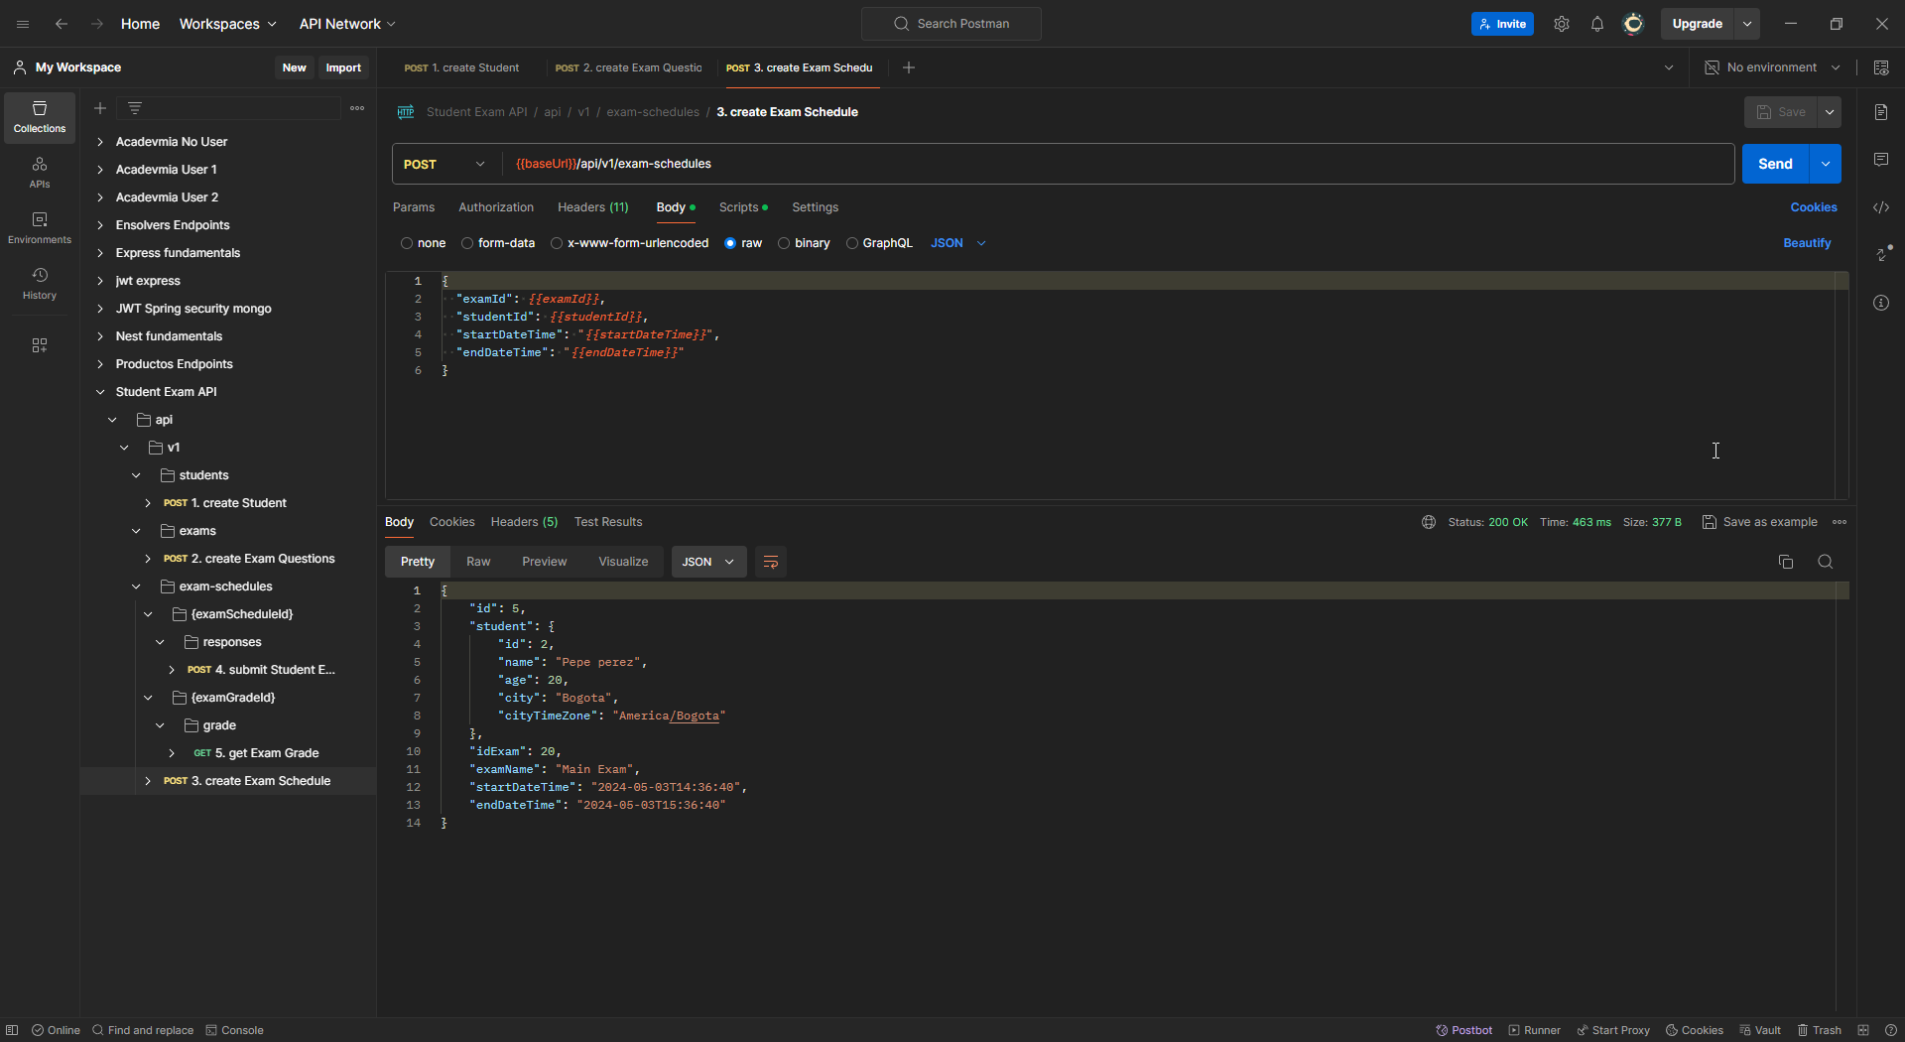

Step 4 =

Here in the body, you should write question IDs (from step 2) and student responses.

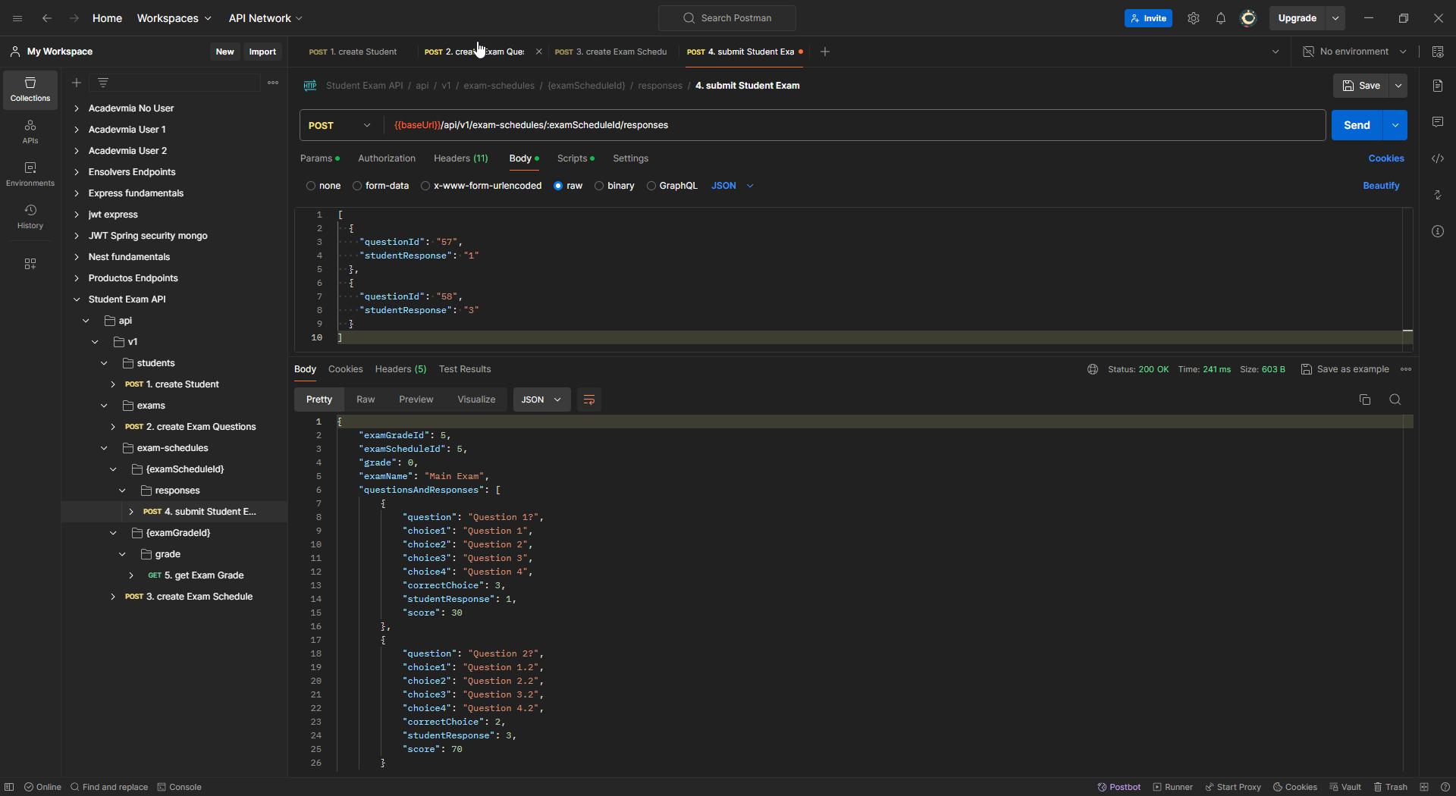

Step 5 =

